**Lesson 2 Action Programming**

# **Project Outcome**

Program an action group to allow robotic arm to grip and place.

This section is just for reference to help you get quick understanding of action programming. If want to refer to the standard action, please go to folder “Appendix->Action Group Files”

# **Complete Program**

## **2.1 Action Programming**

Step 1: Switch on the robotic arm. Then connect it to the computer and open PC software.

Step 2: Double click to open PC software. Click “open action file” and select “00” action file. Then click “online running” to update the servo value on the left side. Now, we get the first action.

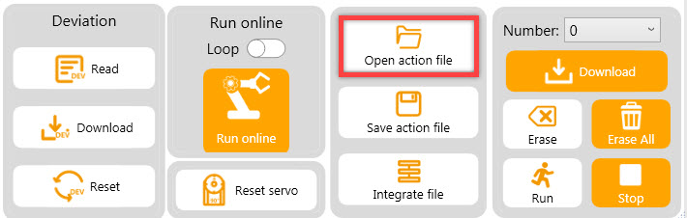

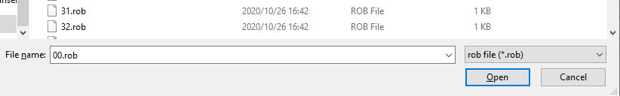

Step 3: Click “Online running” to run the selected action group.

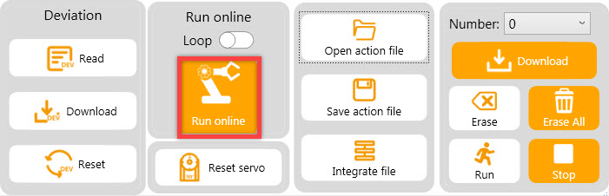

Step 4: Program the robotic arm to bend forward. In servo control area, drag the sliders of ID3, ID4, ID5 servos to the corresponding value, as the figure shown below.

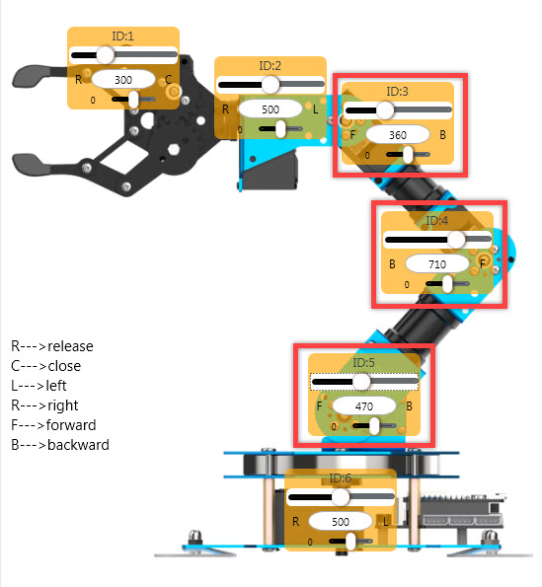

Step 5: Click “Add action” to add the second action to the action data list.

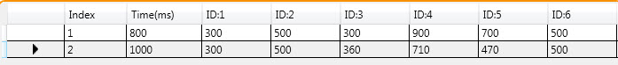

Step 6: Right click No.2 action and select “Copy”.

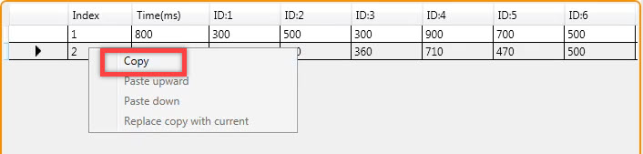Step 7: Then right click “paste down” in black area, and then modify the running

time to “200ms”, which are the preparation of the next action.

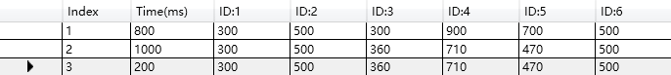

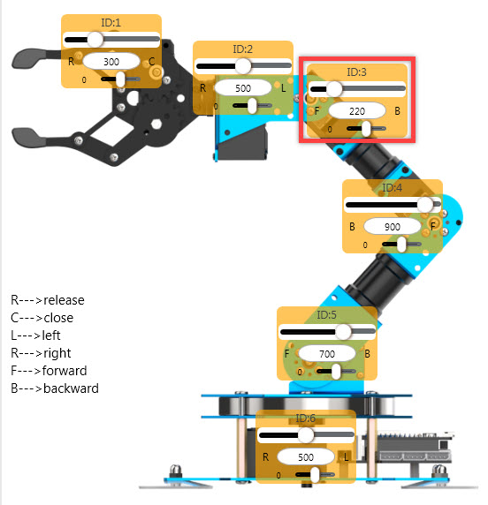Step 8: Program to lower the robotic arm a little bit to get to above the target object. Make a fine adjustment of No.3 servo and set the running time to 800ms.

Step 9: Program to lower the robotic arm again to close to the center of object. Then adjust No.4 servo and set the time to 700ms.



Step 10: Program to let the robotic arm to grip the object. Adjust ID1 servo.



Step 11: Copy the No.6 action as No.7 action, a transition action, and then set the time to 200ms.



Step 12: After gripping object, raise the arm and set the time to 700ms. Then copy this action as a transition action and set the time to 400ms.

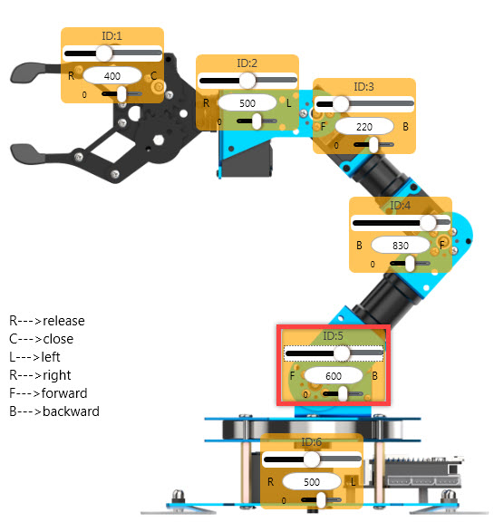



Step 13: Adjust No.6 servo. Then adjust the servo 6 to rotate the base.



Step 14: Copy No.10 action as a transition action. Then set the time to 100ms.



Step 15: After getting to the designated position, lower the robotic arm. You just need to adjust ID5 servo. In addition, copy this action as a transition action and set the running time to 2ooms.



Step 16: Adjust No.1 servo to release the gripper to put down the block, and copy this action as a transition action.



Step 17: Set the robotic arm back to the initial position. Raise the robotic arm first. Then paste No.1 action, initial posture, to the last action.



The following table is the complete action group data:

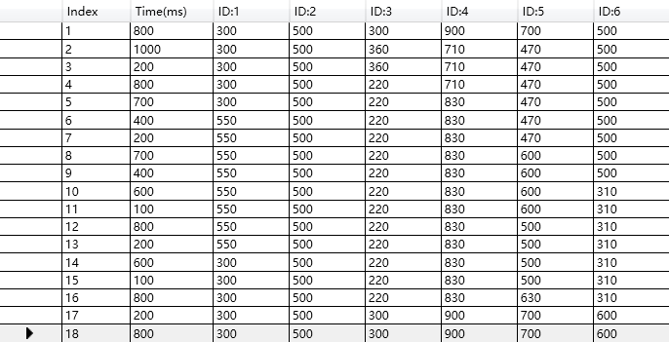

## **2.1 Action Download**

Step 1: After programming, click “save action file” to save the file for the future debugging. Name this action group file as “20”.

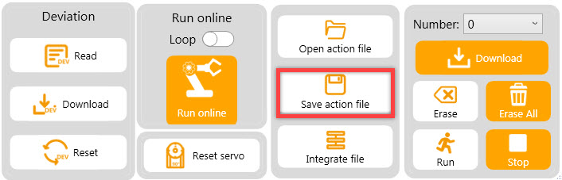

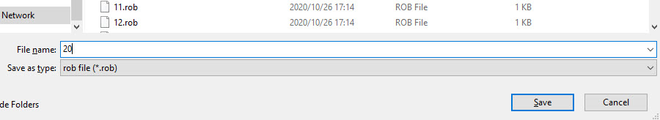

Step 2: After saving the file, download the action group into xArm ESP32. Select number “20” and click “download”.

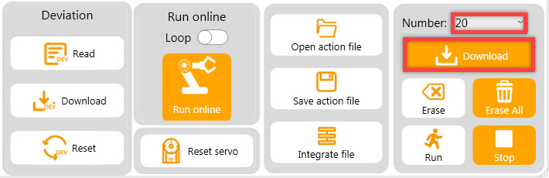

The prompt “Download complete” will pop up in the interface. Click “OK” to close it.